Business Template

Political Campaign
Gulem Toktamys

Contents
1 Business Description 3
1.1 Business background 3
1.2 Problems. Current Situation 3
1.3 The benefits of implementing a database. Project Vision 3
2 Model description 3
2.1 Definitions & Acronyms 3
2.2 Logical Scheme 3
2.3 Objects 3

Business Description

Business background
The political campaign lifecycle spans voter outreach, volunteer coordination, fundraising, event management, and issues tracking. Campaign teams, election commissions, and auditors require a reliable centralized system to collect and analyze voter demographics, donations, volunteer assignments, surveys, and incidents reported during campaign activities. A structured database supports operational efficiency, compliance, and transparent reporting.

Problems. Current Situation
Election-related data is often fragmented across spreadsheets and disparate applications. This leads to:
- Data duplication and inconsistent records (e.g., multiple entries for the same donor or volunteer).
- Difficulty correlating donors to donations, volunteers to tasks, and events to reported issues.
- Limited ability to generate accurate finance and compliance reports.
- Slow manual reconciliation between voter lists, survey results, and event outcomes.
These issues increase the risk of errors and reduce the campaign's ability to make timely data-driven decisions.

the Benefits of implementing a database. Project Vision
Implementing a centralized relational database will:
- Eliminate redundant data entries and enforce data consistency via PK/FK constraints.
- Provide unified views of donors, donations, volunteers, events, surveys and election issues.
- Enable accurate financial reporting and transparency for audits.
- Improve volunteer scheduling and event staffing via M:N relationships and assignment tracking.
- Facilitate analytics (e.g., survey analysis, donor segmentation, and issue trends) that support strategic campaign decisions.
The project vision is to deliver a normalized, auditable database (3NF) that serves as the single source of truth for campaign operations and reporting

Model description

Definitions & Acronyms
PK – Primary Key
FK – Foreign Key
M:N – Many-to-Many Relationship
1:N – One-to-Many Relationship
3NF – Third Normal Form (no transitive dependencies)
ERD – Entity Relationship Diagram
VARCHAR(n) – Variable length character string
INT – Integer
DECIMAL(p,s) – Numeric with precision p and scale s
DATE – Calendar date type

Logical Scheme
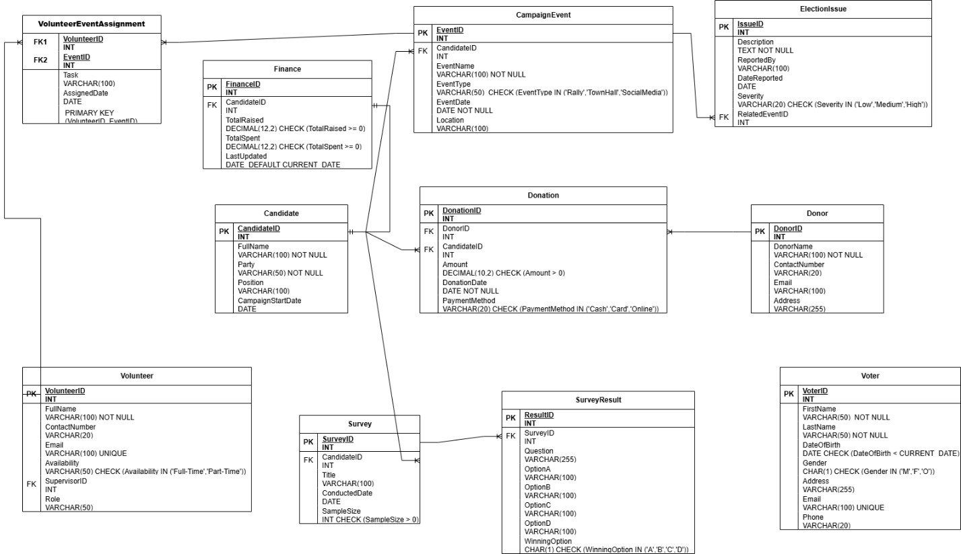

Objects

Table Description
Below are the table definitions (Table Name, Field name, Field Description, Data Type, Comments (PK/FK)).

Table Name | Field name | Field Description | Data Type
voter | VoterID | Unique identifier for voter,PK | Int
voter | FirstName | Given name, NOT NULL | VARCHAR(50)
 | LastName | Family name, NOT NULL | VARCHAR(50)
 | DateOfBirth | Birth date, CHECK (DateOfBirth < CURRENT_DATE) | DATE
 | Gender | Gender code, CHECK (Gender IN ('M','F','O')) | CHAR(1)
 | Email | Email address, UNIQUE | VARCHAR(100)
 | Phone | Contact number | VARCHAR(20)
 | District | Electoral district name | VARCHAR(100)
 | State | state within the country | VARCHAR(100)
 | Locality | City | VARCHAR(100)
 | Street | Street name | VARCHAR(100)
 | Building | Building or house number | VARCHAR(100)

This table is independent within the database model and does not have direct foreign key relationships with other tables. However, voter information can be referenced in analytical queries or survey modules for demographic analysis and election statistics.

Example with data

VoterID | FirstName | LastName | DateOfBirth
1 | Aida | Serikova
  1998-03-15
Gender | Email | Phone | District
F | aida.s@mail.kz | +77011234567
  Almaty District 3
State | Locality | Street | Building
Almaty Region | Almaty | Abai Avenue | 5A

Table Name | Field name | Field Description | Data Type
Candidate | CandidateID | Unique candidate identifier,PK | Int
Candidate | FullName | Candidate full name, NOT NULL | VARCHAR(100)
 | PartyID | Political party id, FK | INT
 | Position | Running position | VARCHAR(100)
 | CampaignStartDate | Campaign start date | DATE

This table has a one-to-many relationship with the CampaignEvent, Donation, and Survey tables through the field CandidateID. It also has a one-to-one relationship with the Finance table through the same key. Each candidate may organize multiple events, receive multiple donations, and conduct several surveys, but will have only one finance record.

Example with data

CandidateID | FullName | PartyID | Position
1 | Aliyev Askar | 1 | President
CampaignStartDate
2025-03-01

Table Name | Field name | Field Description | Data Type
Party | PartyID | Unique party identifier,PK | Int
Party | PartyName | party full name, NOT NULL, UNIQUE | VARCHAR(100)

This table has a one-to-many relationship with the Candidate table through the field PartyID.
Each party can have multiple candidates participating in different campaigns, but each candidate belongs to only one party.
This relationship ensures data consistency and eliminates redundancy by storing party information in a separate entity.
Example with data

PartyID | PartyName
1
  People's Choice

Table Name | Field name | Field Description | Data Type
CampaignEvent | EventID | Unique event identifier,PK | Int
CampaignEvent | CandidateID | Event host candidate, FK | INT
 | EventName | Name/title of event, NOT NULL | VARCHAR(100)
 | EventType | Type of event , CHECK (EventType IN ('Rally','TownHall','SocialMedia')) | VARCHAR(50)
 | EventDate | Date of event,NOT NULL | DATE
 | Location | Event location, | VARCHAR(100)

This table has a many-to-one relationship with the Candidate table through the foreign key CandidateID. It also has a one-to-many relationship with the ElectionIssue table through EventID. Additionally, it participates in a many-to-many relationship with the Volunteer table, implemented via the VolunteerEventAssignment junction table.

Example with data

EventID | CandidateID | EventName | EventType
1 | 11 | Central Rally | Rally
EventDate | Location
 | Astana Square
  2025-05-12

Table Name | Field name | Field Description | Data Type
Volunteer | VolunteerID | Unique volunteer identifier,PK | Int
Volunteer | FullName | Volunteer name, NOT NULL | VARCHAR(100)
 | ContactNumber | Phone number | VARCHAR(20)
 | Email | Volunteer email, UNIQUE | VARCHAR(100)
 | Availability | Availability status, CHECK (Availability IN ('Full-Time','Part-Time')) | VARCHAR(50)
 | SupervisorID | Volunteer supervisor reference, (Volunteer.VolunteerID) | INT
 | Role | Assigned role | VARCHAR(50)

This table has a one-to-many self-referential relationship through the field SupervisorID, which references another record in the same Volunteer table. It also participates in a many-to-many relationship with the CampaignEvent table, implemented through the VolunteerEventAssignment table using the field VolunteerID.

Example with data

VolunteerID | FullName | ContactNumber | Email
1 | Dina Tulegenova |  | dina.t@mail.kz
  +77033445566
Availability | SupervisorID | Role
 | 101 | Assistant
  Full-Time

Table Name | Field name | Field Description | Data Type
VolunteerEventAssignment | VolunteerID | Assigned volunteer,FK | Int
VolunteerEventAssignment | EventID | Assigned event,FK | INT
 | Task | Task description | VARCHAR(100)
 | AssignedDate | Date of assignment, DEFAULT CURRENT_DATE | DATE
 | PK | Composite primary key | Composite PK

This table serves as a bridge (junction) table that resolves the many-to-many relationship between Volunteer and CampaignEvent tables. It includes composite keys (VolunteerID, EventID) that reference the primary keys of both parent tables. Each record represents one volunteer’s specific assignment for a given event.

Example with data

VolunteerID | EventID | Task | AssignedDate
101 | 201 | Stage Setup | 2025-05-10

Table Name | Field name | Field Description | Data Type
Donor | DonorID | Unique donor identifier, PK | Int
Donor | DonorName | Donor full name or organization, NOT NULL | VARCHAR(100)
 | ContactNumber | Phone number, | VARCHAR(20)
 | Email | Donor email | VARCHAR(100)
 | Address | Postal address | VARCHAR(255)

This table has a one-to-many relationship with the Donation table through the foreign key DonorID. Each donor may make multiple donations, but every donation is linked to exactly one donor.

Example with data

DonorID | DonorName | ContactNumber | Email
301 |  |  | contact@nurcorp.kz
  NurCorp Ltd.
  +77055667788
Address
Astana, 12 Republic Ave

Table Name | Field name | Field Description | Data Type
Donation | DonationID | Unique donation, PK | Int
Donation | DonorID | Donor reference, FK | INT
 | CandidateID | Beneficiary candidate, FK | INT
 | Amount | Donation amount ,CHECK (Amount > 0) | DECIMAL(10,2)
 | DonationDate | Date of donation, NOT NULL | DATE
 | PaymentMethod | Payment type, CHECK (PaymentMethod IN ('Cash','Card','Online')) | VARCHAR(20)

This table has a many-to-one relationship with both the Donor and Candidate tables through the foreign keys DonorID and CandidateID. Each donation is associated with one donor and one candidate, creating a linkage between financial contributors and campaign beneficiaries.

Example with data

DonationID | DonorID | CandidateID | Amount
401 | 301 | 11
  5000.00
DonationDate | PaymentMethod
 | Online
  2025-04-15

Table Name | Field name | Field Description | Data Type
Survey | SurveyID | Unique survey identifier, PK | Int
Survey | Title | Survey title | VARCHAR(100)
 | CandidateID | Beneficiary candidate, FK | INT
 | ConductedDate | Date conducted | DATE
 | SampleSize | Number of respondents, CHECK (SampleSize > 0) | INT

This table has a many-to-one relationship with the Candidate table through the field CandidateID. It also has a one-to-many relationship with the SurveyResult table through SurveyID. Each survey is linked to one candidate but can contain multiple questions and responses.

Example with data

SurveyID | Title | CandidateID | ConductedDate
501 | Public Approval 2025 | 11
  2025-06-01
SampleSize
1200

Table Name | Field name | Field Description | Data Type
SurveyResult | ResultID | Unique survey result identifier, PK | Int
SurveyResult | SurveyID | Survey reference, FK | INT
 | Question | Survey question text | VARCHAR(255)
 | OptionA | Option A text | VARCHAR(100)
 | OptionB | Option B text | VARCHAR(100)
 | OptionC | Option C text | VARCHAR(100)
 | OptionD | Option D text | VARCHAR(100)
 | WinningOption | Winning option code, CHECK (WinningOption IN ('A','B','C','D')) | CHAR(1)

This table has a many-to-one relationship with the Survey table through the foreign key SurveyID. Each record in SurveyResult corresponds to a single question or result within a specific survey.

Example with data

ResultID | SurveyID | Question | OptionA
601 | 501 | “Do you support Candidate Aliyev?” | Yes
OptionB | OptionC | OptionD | WinningOption
No | Neutral |  | A
  No Answer

Table Name | Field name | Field Description | Data Type
ElectionIssue | IssueID | Unique survey result identifier, PK | Int
ElectionIssue | Description | Detailed description of the issue, NOT NULL | TEXT
 | ReportedBy | Who reported | VARCHAR(100)
 | DateReported | Date reported | DATE
 | Severity | Issue severity, CHECK (Severity IN ('Low','Medium','High')) | VARCHAR(20)
 | RelatedEventID | Event reference, FK | INT

This table has a many-to-one relationship with the CampaignEvent table through the foreign key RelatedEventID. Each issue reported during the campaign is associated with a specific event, allowing the system to track operational problems or incidents by event.

Example with data

IssueID | Description | ReportedBy | DateReported
701 | Missing chairs at Town Hall | Bulat Karim | 2025-05-20
Severity | RelatedEventID
Low | 202

Table Name | Field name | Field Description | Data Type
Finance | FinanceID | Unique finance record id, PK | Int
Finance | CandidateID | Candidate reference,FK, UNIQUE | INT
 | TotalRaised | Total funds raised, CHECK (TotalRaised >= 0) | DECIMAL(12,2)
 | TotalSpent | Total funds spent, CHECK (TotalSpent >= 0) | DECIMAL(12,2)
 | LastUpdated | Last update date, DEFAULT CURRENT_DATE | DATE

This table has a one-to-one relationship with the Candidate table through the foreign key CandidateID. Each candidate has exactly one corresponding finance record that stores total funds raised and total funds spent, ensuring financial transparency and integrity.

Example with data

FinanceID | CandidateID | TotalRaised | TotalSpent
801 | 11 | 125000.00
  87000.00
LastUpdated
2025-06-10

